A000-AFR-Egy-Ushabti-Hieroglyphs-Blue Faience-Late Period- 664 - 332 BCE

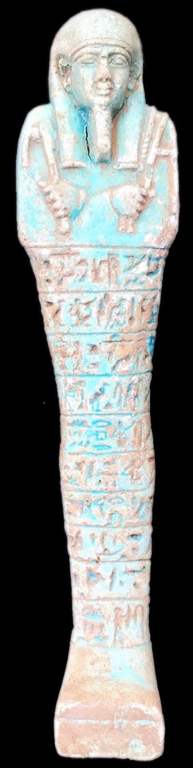

Ushabti-Hieroglyphs-Blue Faience-Late Period- 525-334 BCE

**Case no.: 2**

**Accession Number:**

**Formal Label:** Ushabti-Hieroglyphs-Blue Faience-Late Period- 525-334 BCE

**Display Description:**

**This** Ushabti of the Late Period has a Plain Lappet wig with 2 bands, plain plinth back-ten horizontal registers of hieroglyphs down the front and glazed in blue faience. The hands are crossed with sleeves with the right hand holding a holding a pick and the left holding a hoe.

**LC Classification:** DT62

**Date or Time Horizon:** Late period, 525-334 BCE.

**Geographical Area: Saqqara, Egypt**

**Map, GPS Coordinates:** 29.85000 31.21667; [29°52′16″N 31°12′59″E](https://tools.wmflabs.org/geohack/geohack.php?pagename=Saqqara&params=29_52_16_N_31_12_59_E_type:landmark)

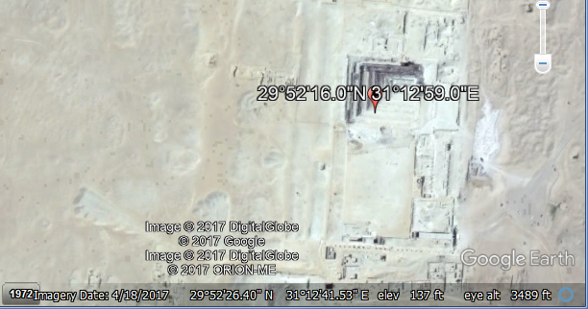

**Cultural Affiliation:** Late Period, Egypt, 525-334 BCE.

**Geographical Area: Saqqara, Egypt**

**Medium:** Blue Faience

**Dimensions:** H 17 cm

**Weight:**

**Condition: Original**

**Provenance:**

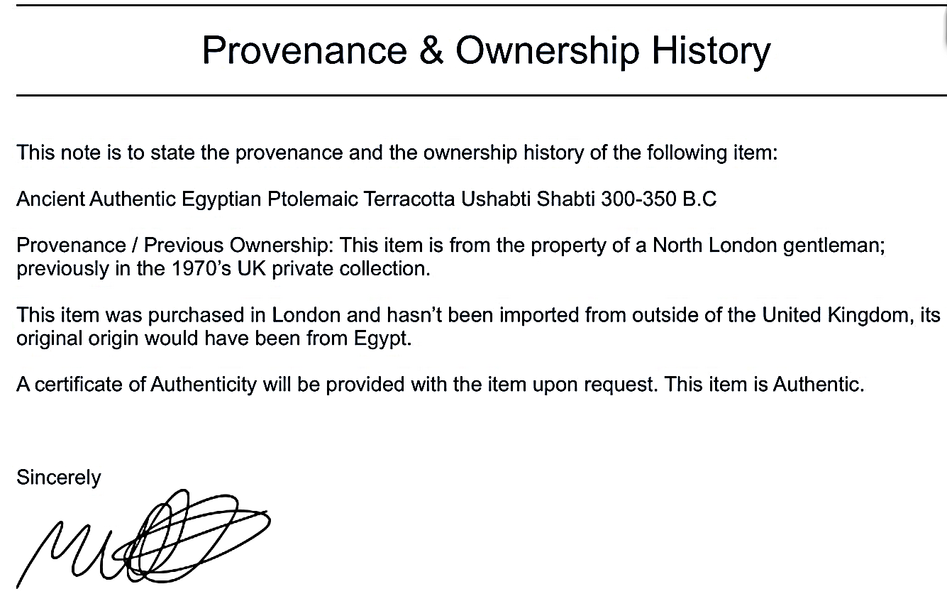

Matthew Wicks

18 Stonedene Close

Forest Row

East Sussex

RH18 5DB

United Kingdom

**Discussion:**

**References:**